Types of SQL Server Views
Views are virtual tables that are compiled at run time. The data associated with views are not physically stored in the view, but it is stored in the base tables of the view. A view can be made over one or more database tables. Generally we put those columns in view that we need to retrieve/query again and again. Once you have created the view, you can query view like as table. We can make index, trigger on view.
In SQL Server we make views for security purpose since it restricts the user to view some columns/fields of the table(s). Views show only those columns that are present in the query which is used to make view. One more advantage of Views is, data abstraction since the end user is not aware of all the data present in database table.
Syntax for View
- CREATE VIEW view_name
- AS
- select_statement[]

Types of Views

In SQL Server there are 2 types of views.

1. System Views
System defined Views are predefined Views that already exist in the Master database of SQL Server. These are also used as template Views for all newly created databases. These system Views will be automatically attached to any user defined database.
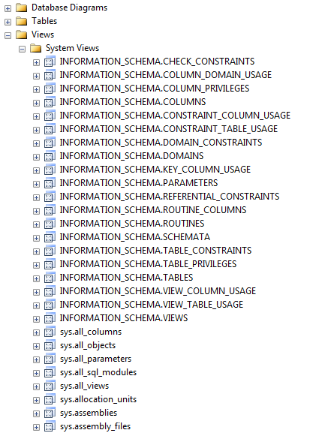

There are 3 types of System Views.
- Information Schema View
In SQL Server we have twenty different schema views. These are used to display information of a database, like as tables and columns. This type of view starts with INFORMATION_SCHEMA and after this view name.
    - --Create a table
    - create table Employee_Test
    - (
    - Emp_ID int identity,
    - Emp_Name varchar(55),
    - Emp_Technology varchar(55),
    - Emp_Sal decimal (10,2),
    - Emp_Designation varchar(20)
    - )
    - --To view detailed information of the columns of table Employee_Test
    - SELECT * FROM INFORMATION_SCHEMA.COLUMNS
    - where TABLE_NAME='Employee_Test'
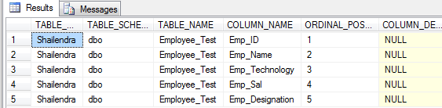
- Catalog View
Catalog Views were introduced with SQL Server 2005. These are used to show database self-describing information.
1. select * from sys.tables
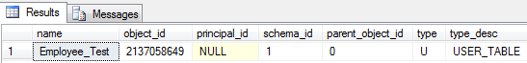

- Dynamic Management View
Dynamic Management Views were introduced in SQL Server 2005. These Views give the administrator information of the database about the current state of the SQL Server machine. These values help the administrator to analyze problems and tune the server for optimal performance. These are of 2 types
- Server-scoped Dynamic Management View
These are stored only in the Master database.
- Database-scoped Dynamic Management View
These are stored in each database.
1. --To see all SQL Server connections
2. SELECT connection_id,session_id,client_net_address,auth_scheme
    - FROM sys.dm_exec_connections
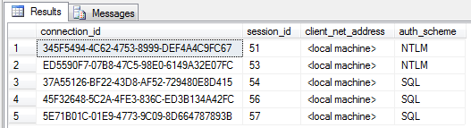

2. User-Defined Views
These types of view are defined by users. We have two types of user defined views.

1. Simple View

When we create a view on a single table, it is called simple view.
    - --Now Insert data to table Employee_Test
    - Insert into Employee_Test values ('Amit','PHP',12000,'SE');
    - Insert into Employee_Test values ('Mohan','ASP.NET',15000,'TL');
    - Insert into Employee_Test values ('Avin','C#',14000,'SE');
    - Insert into Employee_Test values ('Manoj','JAVA',22000,'SSE');
    - Insert into Employee_Test values ('Riyaz','VB',18000,'TH');
    - -- Now create view on single table Employee_Test
    - create VIEW vw_Employee_Test
    - AS
    - Select Emp_ID ,Emp_Name ,Emp_Designation
    - From Employee_Test
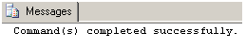
1. – Query view like as table
2. Select * from vw_Employee_Test

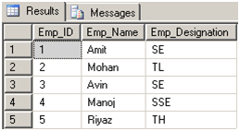

In simple view we can insert, update, and delete data. We can only insert data in simple view if we have primary key and all not null fields in the view.
    - -- Insert data to view vw_Employee_Test
    - insert into vw_Employee_Test(Emp_Name, Emp_Designation) values ('Shailu','SSE')
    - -- Now see the affected view
    - Select * from vw_Employee_Test
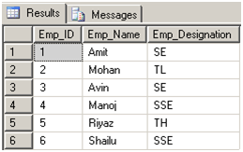
    - -- Update data to view vw_Employee_Test
    - Update vw_Employee_Test set Emp_Name = 'Pawan' where Emp_ID = 6
    - -- Now see the affected view
    - Select * from vw_Employee_Test
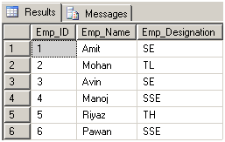
    - -- Delete data from view vw_Employee_Test
    - delete from vw_Employee_Test where Emp_ID = 6
    - -- Now see the affected view
    - Select * from vw_Employee_Test
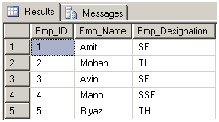

2. Complex View
When we create a view on more than one table, it is called complex view.
    - --Create another table
    - create table Personal_Info
    - (
    - Emp_Name varchar(55),
    - FName varchar(55),
    - DOB varchar(55),
    - Address varchar(55),
    - Mobile int,
    - State varchar(55)
    - )
    - -- Now Insert data
    - Insert into Personal_Info values ('G.Chaudary','22-10-1985','Ghaziabad',96548922,'UP');
    - Insert into Personal_Info values ('B.S.Chauhan','02-07-1986','Haridwar',96548200,'UK');
    - Insert into Personal_Info values ('A.Panwar','30-04-1987','Noida',97437821,'UP');
    - Insert into Personal_Info values ('H.C.Patak','20-07-1986','Rampur',80109747,'UP');
    - Insert into Personal_Info values ('M.Shekh','21-10-1985','Delhi',96547954,'Delhi');
    - -- Now create view on two tables Employee_Test and Personal_Info
    - Create VIEW vw_Employee_Personal_Info
    - As
    - Select e.Emp_ID, e.Emp_Name,e.Emp_Designation,p.DOB,p.Mobile
    - From Employee_Test e INNER JOIN Personal_Info p
    - On e.Emp_Name = p. Emp_Name


    - -- Now Query view like as table
    - Select * from vw_Employee_Personal_Info
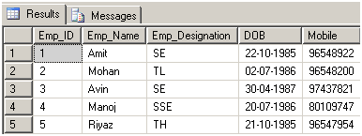
We can only update data in complex view. We can't insert, update data in complex view.
    - --Update view
    - update vw_Employee_Personal_Info set Emp_Designation = 'SSE' where Emp_ID = 3
    - -- See affected view
    - Select * from vw_Employee_Personal_Info
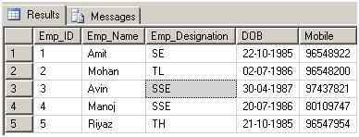

Note
- We make views for security purpose since it restricts the user to view some columns/fields of the table(s).
- One more advantage of Views is, data abstraction since the end user is not aware of all the data present in database table

Types of Views
SQL Server 2008 R2

You can create standard views, indexed views, and partitioned views.

Standard Views

Combining data from one or more tables through a standard view lets you satisfy most of the benefits of using views. These include focusing on specific data and simplifying data manipulation.

Indexed Views

An indexed view is a view that has been materialized. This means it has been computed and stored. You index a view by creating a unique clustered index on it. Indexed views dramatically improve the performance of some types of queries. Indexed views work best for queries that aggregate many rows. They are not well-suited for underlying data sets that are frequently updated.

Partitioned Views

A partitioned view joins horizontally partitioned data from a set of member tables across one or more servers. This makes the data appear as if from one table. A view that joins member tables on the same instance of SQL Server is a local partitioned view.

Note
The preferred method for partitioning data locally is through partitioned tables. For more information, see Partitioned Tables and Indexes.

When a view joins data from tables across servers, it is a distributed partitioned view. Distributed partitioned views are used to implement a federation of database servers. A federation is a group of servers administered independently, but which cooperate to share the processing load of a system. Forming a federation of database servers by partitioning data is the mechanism that lets you scale out a set of servers to support the processing requirements of large, multi-tiered Web sites.

